**National road accident statistics submitted by the Swedish Bus and Coach Federation, Sweden**

In Sweden, there were 286 fatalities resulting from road accidents during 2012. That is 33 less compared with 2011 and a reduction of 10 per cent.

The number of those severely injured during 2012 was 2,976, a reduction from 3,127 during 2011.

Positive developments over the last few years in Sweden can partly explain the reduction in road safety figures, with improved vehicles, infrastructure and reduced speed limits also contributing.

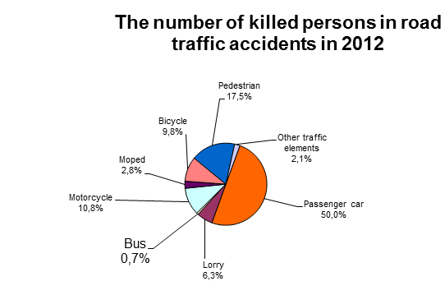

|  |  |  |
| --- | --- | --- |
| **Traffic elements** | **The number fatalities** | **The number fatalities and those severely injured** |
| Passenger car | 143 | 1,889 |
| Passenger car with trailer or caravan | - | 11 |
| Heavy lorry | 2 | 32 |
| Heavy lorry with trailer | - | 9 |
| Light lorry | 13 | 89 |
| Light lorry with trailer | - | - |
| Lorry (unknown weight) | 3 | 24 |
| Bus | 2 | 27 |
| Heavy motorcycle | 27 | 182 |
| Light motorcycle | 1 | 12 |
| Motorcycle (unknown weight) | 3 | 84 |
| Unknown motor vehicle | - | 1 |
| Moped class 1 | 4 | 93 |
| Moped class 2 | 3 | 32 |
| Moped (unknown class) | 1 | 9 |
| Bicycle | 28 | 343 |
| Pedestrian | 50 | 372 |
| Other traffic elements | 6 | 53 |
| **Total:** | **286** | **3,262** |

* * * * *