**National road accident statistics submitted by IRHA, Ireland**

Road deaths in the Republic of Ireland have fallen to the lowest level they have been since records were first officially taken in 1959. The rate of fatalities per million population is now 41, less than half of the rate in 2001 (107).

Road deaths in Ireland have decreased year on year since 2005 with 2011 being the lowest since 1959. In 2001, the fatality rate per million registered vehicles was 232. By 2011, the rate had fallen to 77 per million registered vehicles.

In 2011, of the 27,093 Garda-recorded motor vehicle traffic collisions, 186 people were killed and 7,235 people were injured of which 472 were seriously injured. 21,863 collisions involved property or material damage only.

The fatality rate per million population was 41 in 2011, a decrease of 13 per cent from the 2010 rate of 47.

*Figure 1: Data Trends in Ireland 2001-2011 - Increasing Motorisation versus a Decreasing Road Toll*

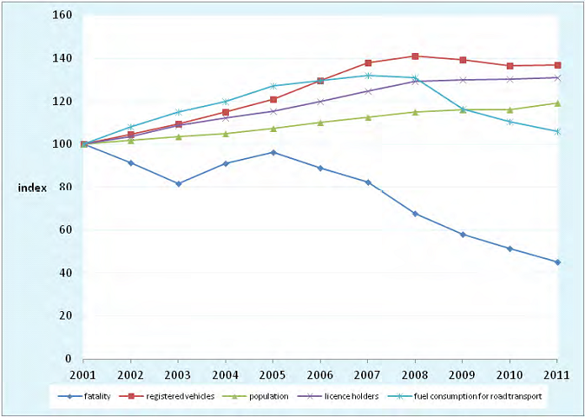

*Figure 2: Number of Fatalities by Transport Mode, 2001-2011*

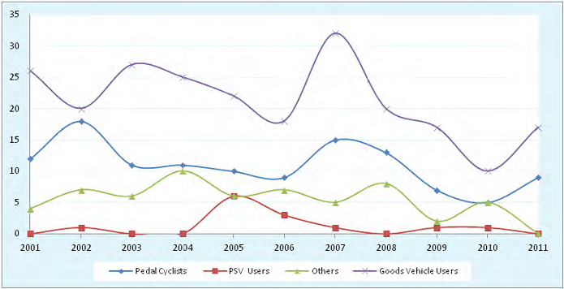

*Vehicles Involved in Fatal and Injury Collisions Classified by Vehicle Type and by Location Type*



    