National road accident statistics submitted by BGL (Germany)

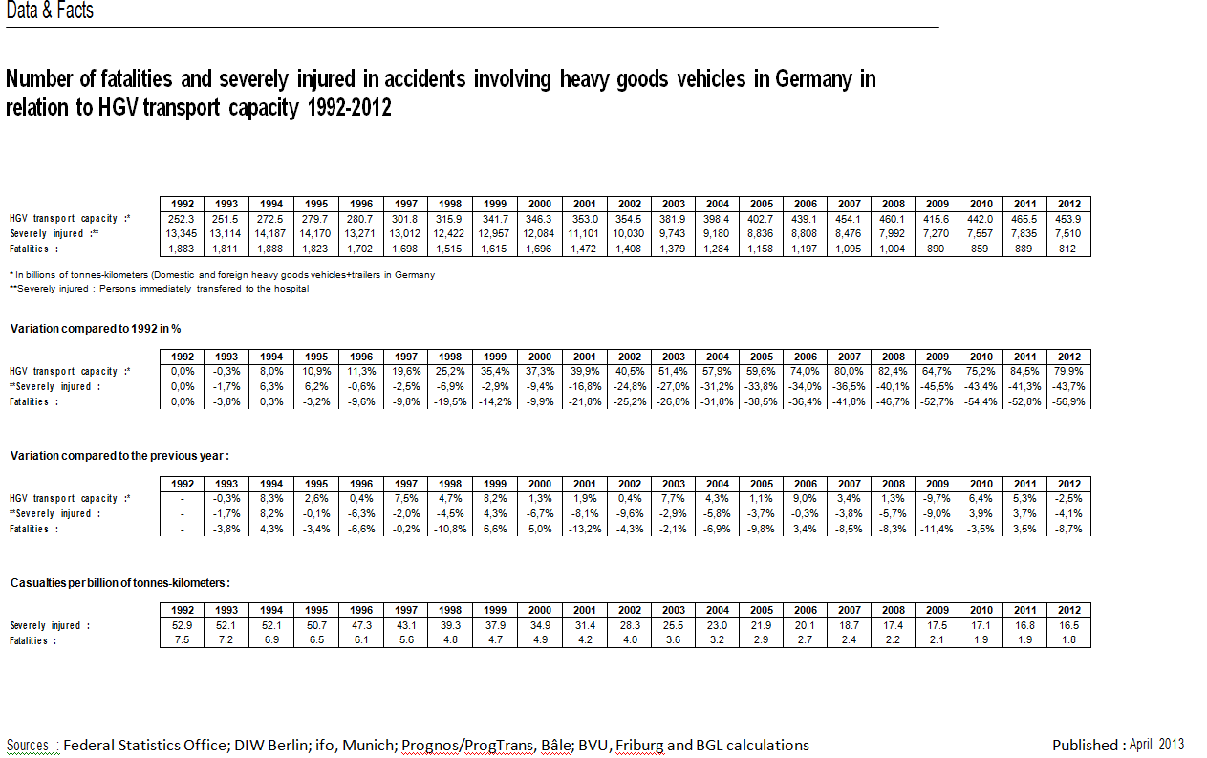
Number of fatalities and severely injured in accidents involving heavy goods vehicles in Germany in relation to HGV transport capacity 1992-2012
Transportleistung in Tonnenkilometern: Transport capacity in tonnes-kilometers / Schwerverletzte: Severely Injured / Getötete: Fatalities
Veränderung gegenüber 1992: Variation in relation with 1992
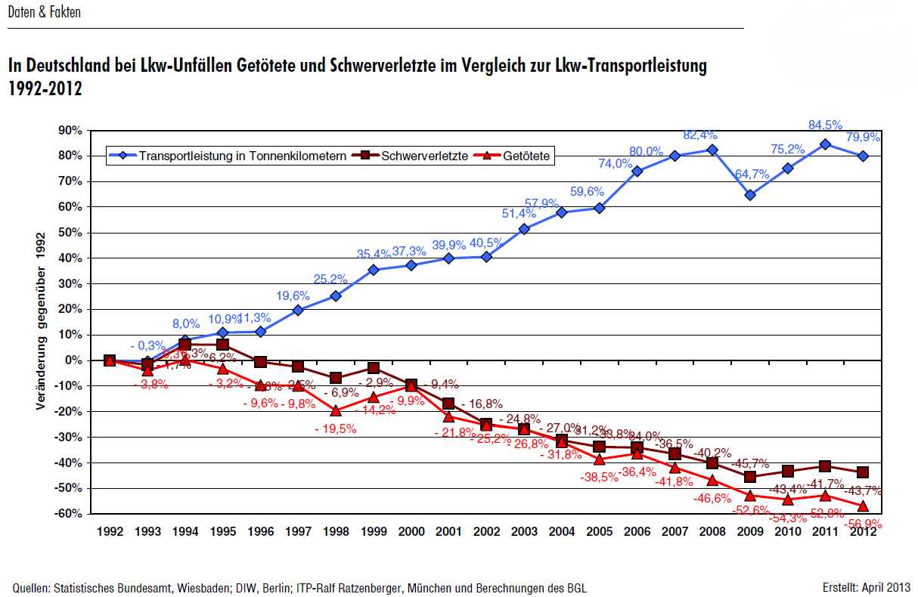Source: Federal Statistics Office; DIW Berlin; ifo, Munich; Prognos/ProgTrans, Bâle; BVU, Friburg and BGL calculations. Published: April 2013.


    

