National road accident statistics submitted by FEBETRA, Belgium
1. Road accident statistics – general trends
Table 1 below provides an overview of the number of fatalities in different regions, at different times of day and with different transport modes (annual total number of fatalities at the accident scene)

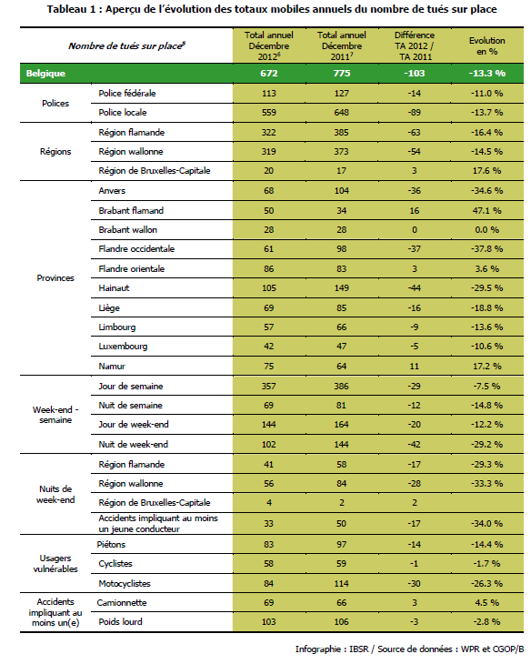
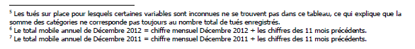

⁵ Fatalities at the scene of the accident with missing variables are not included in this table, which explains why the sum of categories does not always match the total number of fatalities recorded.
⁶ annual total for December 2012 = figure for December 2012 + figures for the 11 previous months.
⁷ annual total for December 2011 = figure for December 2011 + figures for the 11 previous months.

These December figures offer an initial overview of the year 2012 as they provide the total number of accidents and casualties from 1 January to 31 December 2012.
This year shows favourable results as the number of fatalities (at the scene of the accident) has decreased by 13.3% compared to 2011, while the number of persons injured dropped by -8.5%. Absolute figures are particularly eloquent as they report 100 fatalities at the scene of the accident with 5,200 injured less than the previous year. The number of injuries also follows a positive trend, with a drop of -7.8% (-3,754).
The 2012 totals include 672 fatalities at the scene of the accident, 56,223 injured and 44,097 accidents with bodily injuries, i.e. the lowest number of casualties and accidents ever recorded since this barometer was created. Such a percentage drop in the number of accident scene fatalities has not been observed since the February 2009 statistics, and no such decrease in the number of accidents has ever been observed.
Based on the number of accident scene fatalities, it may be possible to produce estimates of the number of fatalities at 30 days, i.e. the official number of road fatalities)⁸ for the year 2012. According to estimates, this number is +/- 750 fatalities at 30 days, which is well on the way to reaching the objective of 630 fatalities at 30 days for 2015 (420 by 2020) set by the 2011 Road Safety Forum (Etats Généraux de la Sécurité Routière). In 2011, Belgium officially counted 858 fatalities at 30 days.
These positive results are partly explained by the comparison with the annual total for the month of December 2011, which showed unfavourable figures (i.e. higher numbers than previous months).
However, the decrease remains significant when comparing with the annual total for November 2011.
According to weather records, precipitation in the year 2012 was above average (both in frequency and intensity) over the period 1981-2010⁹. These specific conditions may have reduced accident occurrence on Belgian roads by reducing the number of users embarking on a trip and urging those who did set off to drive more cautiously.
Whereas certain months with particularly adverse weather conditions (February, April and June) indeed recorded a major drop in the number of accidents (and fatalities) in relation to previous years, more moderate decreases also affect other months where the weather was closer to seasonal averages.
Therefore, weather conditions alone cannot justify the significant decrease in the number of accidents and fatalities.
There could be a structural downward trend (brought on by improvements to vehicles and infrastructure and by a progressive change in road user behaviour) which, from one year to the other, could be either impaired or strengthened by various specific events, such as the weather. Indeed, the year 2012 is in line with a trend which, since 2005, has alternately seen a succession of “decrease years” and “stabilisation years” in relation to the number of fatalities. Moreover, Europe has also recorded a drop in fatalities in 2012 (by -9%), which also followed the year 2011 with mixed results (-2% fatalities)¹⁰.

Table 2: Annual total of figures for December 2012 – National figures (Number of accidents resulting in injuries, Number of accident scene fatalities, Number of casualties, Total accident severity)
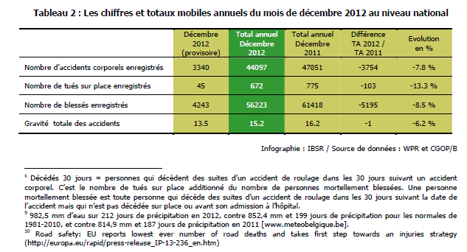

⁸ Fatalities at 30 days = persons who die as a result of a road accident within 30 days, i.e. the number of accident scene fatalities plus the number of fatally injured. A fatally injured person is a person who dies within 30 days of a road accident, but who did not die at the scene of the accident or before being admitted to hospital.

Annual totals of accident scene fatalities (Graph 7) and accidents resulting in injuries (Graph 8) recorded in Belgium
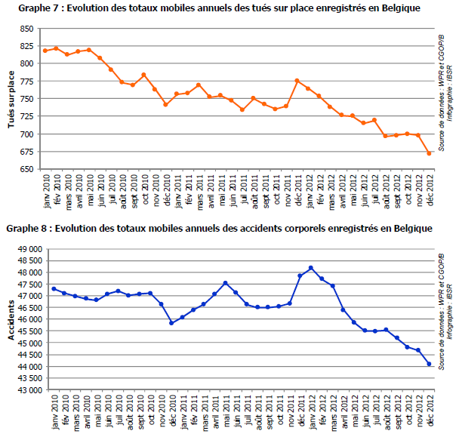

Graph 9: Total severity of accidents resulting in injuries recorded in Belgium

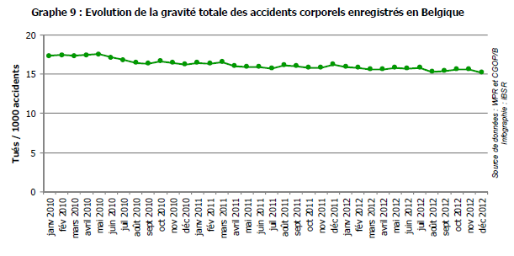

2. Trend for accidents involving heavy goods vehicles
For about a year, the number of accidents involving at least one heavy goods vehicle has shown a downward trend resulting in a decrease of 90 units (-4.0%) compared to the annual total in December 2011.
After having significantly decreased between the annual total of June 2011 and that of May 2012, the number of fatalities caused by accidents involving heavy goods vehicles (whether or not they were inside the truck) has risen again. Although this is not reflected in the comparison with the annual total in December 2011, the increase was close to 20 fatalities compared to the annual total in May 2012.
Accident severity has therefore also risen, from 34.7 fatalities per 1,000 accidents as the annual total in May 2012 to a total of 47.2 in December 2012.
Over two thirds of the total decrease in the number of accidents involving a heavy goods vehicle occurred in the French-speaking part of Belgium, with a drop of 64 accidents out of a total of 90. The other third occurred in Flanders. In terms of fatalities as a result of these accidents, the figures are relatively stable across all 3 regions, although the drop in Flanders is 9 units compared to last year.
Table 13: Annual total of accidents involving at least one heavy goods vehicle, for December 2012

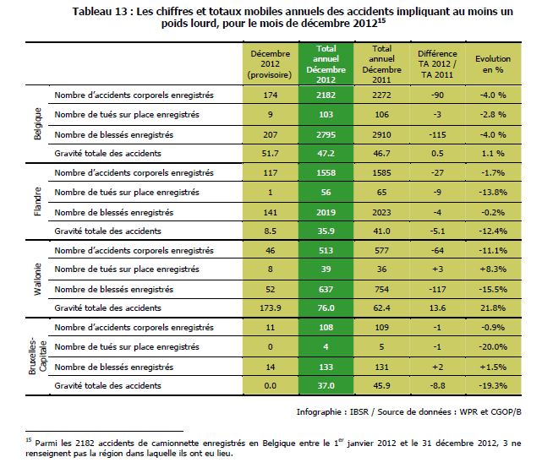

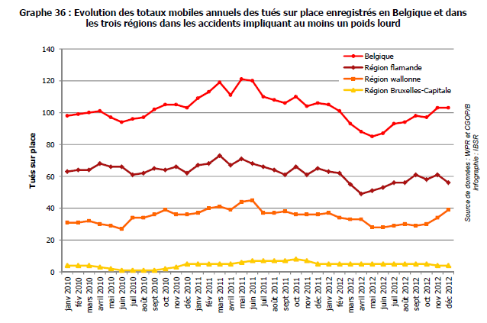

Annual total of accident scene fatalities (Graph 36) and accidents resulting in injuries (Graph 37) involving at least one heavy goods vehicle

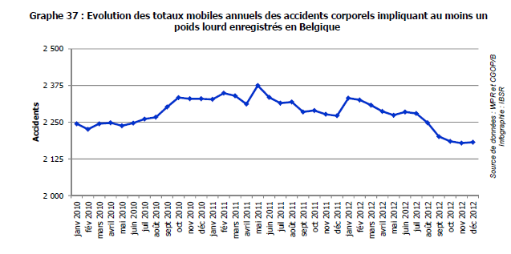
Source: “Baromètre de la sécurité routière” brochure by the Belgian Road Safety Institute (Institut Belge pour la Sécurité Routière)

* * * * *

